13th Annual Commemorative Lecture in Mexican American History

“The Republic of the Rio Grande: A Historical Orphan”
What:  When:  Where:  Cost:  Sponsor: | “The Republic of the Rio Grande: A Historical Orphan” — A lecture at the University of North Texas by Dr. Beatriz de la Garza, writer, author, lawyer, elected public official and historian, Austin, Texas. UNT’s 13th Annual Commemorative Lecture in Mexican American History.  February 6, 2014 (Thursday), 4:30 p.m.  Business Leadership Building, Room 80, University of North Texas campus  Free—Public Invited  Mexican American Studies Minor and the Department of History, College of Arts and Sciences (CAS)

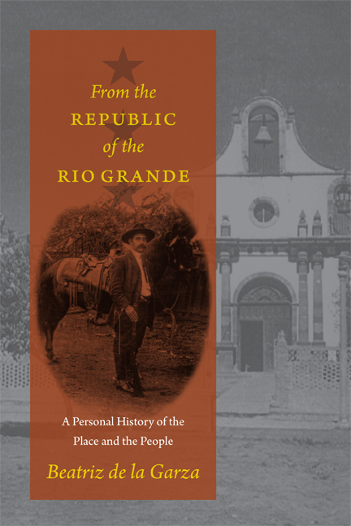
Beatriz de la Garza is the author of From the Republic of the Rio Grande: A Personal History of the Place and the People (UT Press, 2013), which received the Jim Parish Award from the Webb County Heritage Foundation. UT Press also published her earlier history, A Law for the Lion: A Tale of Crime and Injustice in the Borderlands (2003). Her books include works of fiction for children and young adults published by Arte Público Press, The Candy Vendor’s Boy and Other Stories (1994) and Pillars of Gold and Silver (1997).

Dr. de la Garza holds four degrees from the University of Texas at Austin including her B.A., M.A., Ph.D., and J.D. She’s been a practicing attorney in Austin, Texas for many years. She’s also been an elected public official. In 1988 she was elected to her first of three terms to the Austin Independent School District (AISD) Board. She served on the AISD School Board from 1988-1994, and during her final term (1992-1994) she served as Board President. This made her the first Mexican American woman (and Latina) ever to hold this elected position in the history of the Texas state capital’s public school district. Dr. de la Garza has also held several visiting professorships in Spanish Language and Literature and Legal Principles for Legal Assistants at her alma mater, the University of Texas at Austin, Austin Community College, and Texas State University in San Marcos.

Born in Ciudad Guerrero, Tamaulipas, otherwise known as Old Revilla, she grew up and attended school in Laredo, Texas.

