You are invited to the
UNT Latino and Mexican American Studies (LMAS) Major
Outstanding Scholar/Artist Lecture

“The Future is Ours: How Latinos will Define the Next Era
in American Politics”
given by
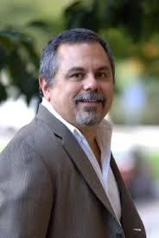
Dr. Gary M. Segura, Professor of American Politics and Chair of Chicano/a Studies at Stanford University, also co-founder and principal in the national polling firm Latino Decisions™
Monday, February 17, 2014, 7pm in the Business Leadership Building, Room 180
Reception with Dr. Segura immediately following at 8 pm.

