THE UNT LATINA/O AND MEXICAN AMERICAN STUDIES (LMAS) PROGRAM
KICKOFF!!

JOIN US FOR A NIGHT OF LMAS!
AN OPPORTUNITY TO LEARN ABOUT THE UNT LMAS PROGRAM, MEET AND MINGLE WITH UNT LMAS FACULTY, AND ENJOY LMAS ORIENTED CULTURAL PERFORMANCES!

DATE: MARCH 21, 2014 WHERE: Business Leadership Building (BLB Atrium and #180)

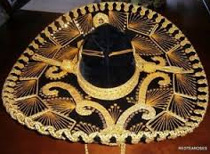
FEATURING:
5:00 P.M. UNT MARIACHI AGUILAS
5:30 P.M. WILSON BALLET FOLKLORICO
6:00 P.M. LMAS PROGRAM AND LMAS FACULTY!
7:30 P.M. JOSE APONTE AND THE UNT LATIN JAZZ LAB + LMAS RECEPTION

LMAS FACULTY:
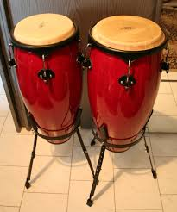
Dr. Yolanda Flores Niemann, Professor/Psychology and Senior Vice Provost
Dr. Gabriel Carranza, Assistant Vice Provost for Global Engagement and
Adjunct Research Professor/Biology
Dr. Alicia Re Cruz, Professor/Anthropology
Dr. Valerie Martinez-Ebers, Professor/Political Science
Dr. Roberto R. Calderón, Associate Professor/History and Mexican American Studies
Dr. Mariela Nuñez-Janes, Associate Professor/Anthropology and Ethnic Studies
Dr. Jaime Javier Rodriguez, Assistant Professor/English
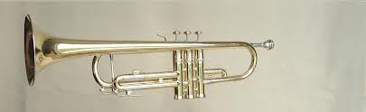
Dr. Lorenzo García, Associate Professor/Chair, Dance and Theatre
Dr. Priscilla Solís Ybarra, Assistant Professor/English
Dr. David Molina, Associate Professor/Interim Chair, Economics
Dr. Guillermo Oyarce, Associate Professor/Library and Information Sciences
Dr. Sandra Mendiola García, Assistant Professor/History
Mr. José Lineros, Lecturer/Accounting and Information Systems
Dr. María Teresa Marrero, Associate Professor/World Languages, Literatures, and Cultures and
Latino/a and Mexican American Theater
Mr. José Aponte, Senior Lecturer/Instrumental-Jazz Studies Division
Dr. Rossana M. Ramírez Boyd, Principal Lecturer/Director, Bilingual-ESL Teacher Certification Programs
Dr. Ricardo González-Carriedo, Assistant Professor/Teacher Education and Administration
Ms. María Z. Muñiz, Principal Lecturer/World Languages, Literatures, and Cultures
Dr. Jacqueline E. Arroyo-Romano, Assistant Professor/Teacher Education and Administration, Division of Education and Human Services, University of North Texas at Dallas
Dr. Leticia Anaya, Senior Lecturer/Engineering Technology and Interim Director, LMAS
SPONSORS: UNT Provost Office and Vice President for Academic Affairs, UNT History Department, UNT Anthropology Department, UNT Sociology Department, UNT English Department, UNT College of Business, UNT College of Arts and Sciences, and UNT Department of Engineering Technology.

For more information, visit http://lmas.unt.edu . Please RSVP at Lanaya@unt.edu or (940) 565-2366.

SPONSORS: UNT Provost Office and Vice President for Academic Affairs, UNT History Department, UNT Anthropology Department, UNT Sociology Department, UNT English Department

