Latino-Black Relations in American Politics
  - A frank discussion between prominent scholars of racial and ethnic politics

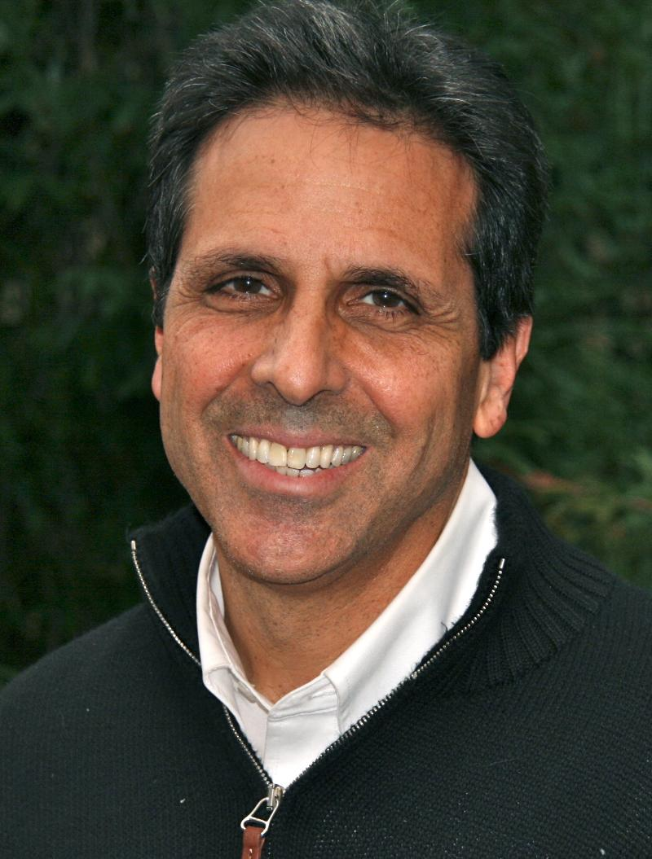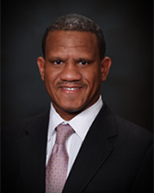
Rodney Hero is President of the American Political Science Association (APSA) and the Haas Chair in Diversity and Democracy at the University of California, Berkeley. His research focuses on American democracy and politics, through the analytical lenses of Latino Politics, Racial/Ethnic Politics, State and Urban Politics and Federalism. His book, Latinos and the U.S. Political System: Two-tiered Pluralism, received the APSA Ralph J. Bunche Award for best book on racial-ethnic politics. His book Faces of Inequality: Social Diversity in American Politics received the Woodrow Wilson Foundation Award for the best book in the nation on Government, Politics or International Relations.
Alvin B. Tillery, Jr. is APSA National Program Chair for 2015 and Associate Professor of Political Science at Northwestern University. His research focuses on American political development, racial and ethnic politics, media and politics and critical race theory. His book Between Homeland and Motherland: Africa, U.S. Foreign Policy and Black Leadership in America won the W.E.B. Du Bois Distinguished Book Award from the National Conference of Black Political Scientists.
Tuesday, February 2, 2015 at 7 pm (Reception following at 8 pm)
Sage Hall, Room 116. (Sponsored by the UNT Department of Political Science and the UNT Latino and Mexican American Studies Program)

