**The Trump Effect: How 2016 Campaign Rallies Explain Spikes in Hate**

**Submitted by**

**Ayal Feinberg**

**Assistant professor**

**Texas A&M University Commerce**

[**ayal.k.feinberg@gmail.com**](mailto:ayal.k.feinberg@gmail.com)

**Regina Branton**

**Professor**

**University of North Texas**

[**branton@unt.edu**](mailto:branton@unt.edu)

**Valerie Martinez-Ebers**

**Professor**

**University of North Texas**

[**valmartinez@unt.edu**](mailto:valmartinez@unt.edu)

**Please do not cite without the explicit permission of the authors.**

**The Trump Effect: How 2016 Campaign Rallies Explain Spikes in Hate**

From June 17th, 2015 to November 7th, 2016, the Trump campaign held over 300 rallies with attendance ranging from a few hundred supporters in school gymnasiums to tens of thousands of devotees overflowing sports stadiums. Our research examines whether these rallies and Trumps rhetoric served as opportunities for the spread of hate by measuring the number of reported white supremacist propaganda, anti-Semitic incidents, and extremist behaviors that occurred both leading up to and directly following these campaign events. We argue that Trump’s rhetoric and rallies served to heighten white identity and increase the perceived threat facing white Americans. Utilizing a negative binomial regression model, we find that counties which hosted a Trump rally saw a 226% increase in hate-motivated incidents. This is among the first research to systematically show that Trump events are correlated with a significant rise in domestic hate.

Word Count: 4,440

From June 17th, 2015 to November 7th, 2016, the Trump campaign held over 300 rallies with attendance ranging from a few hundred supporters in school gymnasiums to thousands of devotees overflowing sports stadiums. Breaking norms of contemporary American political discourse, fiery speeches at these rallies often employed contentious language which, regardless of intention, closely mirrored narratives of prominent U.S. white nationalists and far-right extremist groups. Unsurprisingly, Trump’s candidacy and election to the Presidency has been frequently celebrated by white nationalists, perhaps most famously by Richard Spencer who on November 20th, 2016, addressed an audience of supporters in Washington D.C., closing his speech with “Hail Trump, hail our people, hail victory” (Lombroso and Appelbaum 2016).

Despite engendering the support of white nationalists across the country, questions regarding the actual effects of Trump’s political rhetoric abound. While several organizations (e.g., ADL 2018) have postulated that the substantial rise in reported hate-motivated incidents across the United States since his election are, in part, the result of Trump-spawned white nationalist enthusiasm, empirical analysis has yet to evaluate this suggested link and its intensity. Concerns related to the behavioral consequences of Trump’s rhetoric climaxed following the massacre of worshipers in the Tree of Life Synagogue on October, 27th, 2018 by a white supremacist obsessed with what he believed was the existential threat the “migrant caravan,” posed to the United States (Levenson and Sanchez 2018). Concerns have remerged following another incident of white nationalist terrorism in El Paso, where the suspected shooter’s manifesto claimed his actions were to counter the “invasion” of Hispanics. Consequently, our research, which examines whether Trump’s political rallies result in increases in reported hate incidents, is more judicious for both scholars and security-oriented practitioners than ever before.

We utilize reported hate, extremism, anti-Semitism, and terrorist activities from the 2016 election year as well as an exhaustive list of all Trump rallies during this period to analyze the role his campaign rallies had on variation of racial and ethnoreligious-motivated incidents across the United States. Our research finds counties hosting a Trump campaign rally are significantly more likely to experience a rise in reported hate incidents in the months following the rally. We argue this finding elucidates a connection Trump’s political rhetoric has on activating prejudicial attitudes and behavior, which ultimately leads to tangible increases in minority targeting.

Our paper proceeds by introducing relevant components of the extant literature on Trump political rhetoric and support, and far-right extremism and the targeting of minority communities. It continues by comparing Trump’s rhetoric during his rallies—namely the promotion of violence, use of ethnic, religious, and racialized language, and support for conspiracy theories—with narratives employed by key white nationalists. Utilizing negative binomial regression models, we demonstrate that counties hosting a Trump rally are significantly more likely to see a spike in reported hate incidents in the subsequent months. We close with a brief discussion of this research’s scholarly, political, and societal implications.

Literature Review

While there are numerous characteristics that distinguished the 2016 presidential election with prior contests, one that both the academy and the media have given considerable thought is the role Trump’s norm-shattering political rhetoric has had on his support and ultimate electoral success. Trump’s communications often bucked contemporary political discourse by employing and articulating content previously rebuked as unacceptable in the political arena, including utilizing negative stereotypes of racial, ethnic and religious groups, advocating a range of conspiracy theories, and promoting violent retaliation of protestors. Scholars (e.g. Blodorn and Blascovich 2018) have attempted to elucidate how elements of this rhetoric has contributed to Trump’s support by underscoring how “the threat of increasing diversity” may make certain White Americans more likely to favor candidates that promulgate an existential risk from out-groups. Lajevardi and Oskooii’s (2018) survey findings underscore a clear connection between “old-fashioned racism” and support for Trump. Others have suggested this rhetorical mainstreaming of the fringe may ultimately result in violence, including the possibility of cyclical violence and the organization of pro-Trump militias to defend against perceived enemies (e.g., Barkun 2017, 437 & 441-442). Our analysis aims at connecting and testing these two agendas,by looking at how Trump rhetoric and rallies maybe related to a rise in the number of incidents targeting minorities.

There are considerable social psychological theories of identity and intergroup relations that demonstrate how certain demographic, ideological, and political realities make outgroup threat more pronounced, which may lead to political positions that discriminate against outgroups (Tajfel & Turner 1979; Stephan & Stephan 2000; McGregor et al. 2009). For example, Stephan & Stephan’s (2000) Integrated Threat Theory utilizes a combination of tangible (competition over resources) and symbolic (destruction of values) threats posed by increasing American diversity to produce increased White American prejudice towards immigrants. This plays into findings that suggest many White Americans perceive diminishing bias towards minorities’ results in increased bias towards Whites, intimating that movement toward equality of all groups threatens White Americans. According to De Jonge (2016), supporters of then presidential candidate Trump frequently exhibited this belief.

Blodorn and Blasovich (2018) find Whites high in ethnic identification are more likely to support Trump and anti-immigrant polices and oppose certain political correctness norms after exposure to an article about increasing demographic diversity. Further, they find increased group status threat and support for Trump is specific to exposed White individuals with high ethnic identification, yet no change among exposed White individuals with low ethnic identification. Relatedly, Craig and Richeson (2014) find Whites became more concerned about Whites’ loss of social status after reading that racial minority groups will comprise a majority of the U.S. population by 2042. While identifying the tangible effects of political rhetoric on White support for candidates or policies that promise to address concerns regarding perceived threats is critical, there are still questions regarding its material effects. Namely, does political rhetoric that feeds into the notion of group status threat inspire people to act on that threat and target minorities believed to be the cause of it? If so, in what intensity?

Demographic-oriented studies of minority targeting indicate that while hate-motivated incidents tend to occur in predominantly white areas, they are most common when those locations experience a rapid influx of minorities (Green et. al 1998, Lyons 2007). States and counties containing a considerable number of ethnic minorities, namely Jews who suffer the highest number and proportion of religion-motivated attacks in America, experience a greater number of hate crimes (Feinberg 2016,).

Studies also find that there is a strong link between active hate groups and minority targeting (e.g., Smithet.al. 2006; Mulholland 2011; Adamaczyk et al. 2014). Scholars have postulated several reasons why this occurs. One factor is practicality. Smithet. al (2006) find the majority of domestic terrorists commit crimes within driving distance of their residences. Another factor is the bandwagon effect. Green & Rich (1998) note acts of domestic terrorism may help inspire others considering similar actions. Most importantly to our analysis, Freilich, et. al (1999) argue hate crimes are correlated around hate group activity because of the frequency in which they encourage its members and supporters to partake in actions targeting minorities, including advocating the use of violence.

White nationalism and hate groups that promote a racialized hierarchy rely on many of the same ideas and utilize much of the same rhetoric expressed during Trump’s rallies. For purposes of comparison, we assess 1) rhetoric focused on negative racial, ethnic and religious stereotypes, 2) the promotion of conspiracy theories, and 3) the justification of violence.

There have been several instances when Trump has evoked negative stereotypes of racial, ethnic and religious minority groups. Perhaps most infamously was Trump’s proposed Muslim Ban in which he said *“[I am] calling for a total and complete shutdown of Muslims entering the United States”* (Blumenfeld 2016). Trump rationalized this decree as necessary for national security, invoking the notion that Islam as a religion and Muslims as a people pose a unique threat to the nation. Another key incident invoking undesirable minority stereotypes was Trump’s quote referring to Mexicans, *“They are bringing drugs. They are bringing crime. They are rapists.”*(Sanchez 2015).This language is often indistinguishable from the contemporary rhetoric of white nationalists.

Trump’s praise for conspiracy theorists such as Alex Jones and his use of conspiracy theories throughout his campaign and into his presidency also mirrors narratives employed by racist hate groups in the United States. For example, on October 13th, 2016 at a rally in West Palm Beach Florida, Trump said, *“Hillary Clinton meets in secret with international banks to plot the destruction of U.S. sovereignty in order to enrich these global financial powers, her special interest friends and her donors”* (Choksi 2016). As chief executive of the Anti-Defamation League noted in a statement following the rally, *“Mr. Trump focuses on the very issues and themes that obsess conspiratorial anti-Semites: They believe that there is an elite group of Jews who control the media, the government, and banking and who are trying to destroy white America”* (Choksi 2016).

During several rallies, Trump also excused the use of violence against those protesting his speeches. On February 1st, 2016, Trump said during a speech, *“If you see somebody getting ready to throw a tomato, knock the crap out of them would you. Seriously. I will pay for the legal fees I promise”* (Banfield 2016). The advocation of violence against political enemies or the ex-post justification of it is commonplace within hate groups.

Theory

While we explicitly do not make any claim that Trump is purposefully urging the criminal targeting of minorities, we do argue political speech which utilizes racial, ethnic and religious tropes, promotes conspiracy and excuses the use of violence, represents a dangerous oratorical cocktail that emboldens group threat and encourages hate groups. This will result in increases in the targeting of minorities. Consequently, counties hosting Trump rallies, which frequently employ this rhetoric, are more likely than other counties to see spikes in reported hate-motivated incidents and extremist activity.

There are several causal reasons that explain our expectation that counties hosting a Trump rally will see increased minority targeting, although limitations in the data of this study cannot evaluate each specifically. First, rally rhetoric can increase a sense of group threat and heighten White identity. Second, there is reason to think that concerns regarding Whites losing out to is already common among many Trump supporters (De Jong 2016). Having their fears confirmed by Trump may bolster action to combat the threat posed by minorities, including actively targeting them. Third, it also may make attendees more susceptible to joining extremist groups that frequently act on their racist beliefs.

A key reason in Trump rhetoric and rallies being a recruitment tool for white nationalism is his frequent engagement in the use of white nationalist dogwhistles, including “globalism” and “globalists.” White nationalists often see globalization as “a deliberately controlled destruction of cultures, traditions, and values (and, ultimately, of nations and peoples),” part of the global and hidden Jewish conspiracy where Jews use their control of the media, banks, and democratic governments to orchestrate white genocide and maintain power (Grumke 2013). Consequently, it is easy to see why Trump’s consistent use of this rhetoric excites white nationalists as recognition of their narratives at the highest level of politics.

Relatedly, hate groups might see Trump rallies as an opportune place to recruit new members. Bakun (2017, 439) notes that 2016 was in fact the first time the radical right had backed a major party candidate. In order to garner the attention of potential supporters as well as distinguish themselves from competing organizations, hate groups keen to take advantage of the recruiting opportunity, may be more prone to act following a Trump rally.

For these reasons, we hypothesize the following:

*Hypothesis 1: In the months following a Trump rally, the hosting county is more likely to report an increase in incidents targeting minorities.*

**Data & Method**

To examine if the 2016 Trump political rallies[1] influenced incidents targeting minorities, we use two key pieces of data. First, we use data compiled by the Anti-Defamation League’s (ADL) Center on Extremism regarding hate incidents reported between January 1, 2016 and December 31, 2016. This data provides information on the city, state, and date of incidents reported during the observed period.[2] Second, we compiled information regarding the city, state, and date of each rally Trump held between January 1, 2016

and December 31, 2016.[3]

We aggregated the incident data and Trump rally data to the county-level. The aggregation of the data is intended to recognize exposure to information (i.e. public knowledge) of a rally likely extended beyond a singular city. Further, the impact of Trump rallies likely extended beyond the city in which a rally occurred. To identify the county in which each Trump rally and hate incidents occurred, we use GIS to locate the county in which each city of a rally and incident is located. To highlight the distribution of Trump rallies, consider Figure 1. The counties in which Trump held a rally are highlighted in blue. This figure clearly illustrates Trump held rallies across the U.S. during 2016.

**<Insert Figure 1 here>**

The dependent variable is a count of the incidents targeting minorities that occurred in each county by month in 2016. The number of county-level incidents by month ranges from 0 to 16 with a mean of .03. Given the count nature of the dependent variable, we use negative binomial regression to estimate the impact of Trump rallies on hate incidents.[4] To demonstrate the variation in county-level hate incidents we present a choropleth map in Figure 2, which depicts the number of hate incidents. The graduated color scheme uses darker colors to reflect a greater number of hate incidents. Substantively, this figure highlights the vast variability in the hate incidents recorded across U.S. counties.

**<Insert Figure 2.here>**

The key independent variable is a dichotomous variable coded “1” if the Trump rally occurred in a county in a given month and “0” if there was not rally. Further, for counties that experienced a Trump rally, once a rally is held, the subsequent months are likewise coded “1.” For example, Trump held a rally in Waukesha County, Wisconsin in September of 2016. Thus, the Trump rally variable for Waukesha County is coded 0 from January thru August and coded 1 for September thru December. Alternatively, Trump did not hold a rally at all in 2016 in Adams County, Washington; thus, the Trump rally variable for Adams County is coded 0 for every month in 2016.

In addition to the key independent variable, the model includes several demographic and contextual control variables. We include a county-level measure of the estimated per capita Jewish population culled from the 2011 North American Jewish Data Bank and the 2011 U.S. Census American Community Survey by Comenetz (2012). The per capita Jewish population ranges from 0 to 28,903.7 with a mean of 315.7. This variable is included based on the expectation that counties with a sizeable Jewish population may experience higher rates of anti-Semitic incidents. The model also includes a state-level measure of the number of hate groups in 2016 as reported by the Southern Poverty Law Center. The number of hate groups ranges from 0 to 79 with a mean of 24.6 groups. As the number of hate groups increases within a state, it is likely the number of incidents targeting minority groups will increase. To control for incidents more generally, the model includes a measure of county-level per capita violent crime and per capita property crime.[5] Both measures were provided by the FBI's 2015 Unified Crime Report.

To account for the partisan makeup of a county, we utilize the measure of the vote share the Republican presidential candidate received in the 2012 election. The partisan measure, *% Rep 2012*, ranges from 7.1 percent to 95.9 percent with a mean of 59.7 percent. Next, to create a county-level measure of socio-economic context, we utilized the 2015 American Community Survey population estimates for college-educated. The measure, *% College*, represents the percentage of the county-level population over the age of 25 that is college educated, which ranges from 3 to 80.2 with a mean of 20.8. To account for regional differences in the dependent variable, the model includes three regional dummy variables: South, Northeast, and Midwest (with West serving as the baseline category).[6] Finally, the model includes a dummy variable for each month to control for unmeasured events that may influence hate incidents.[7] Given that the general election was held in November 2016, this month serves as the baseline category.

**Predicting Extremist and Anti-Semitic Incidents**

Table 1 presents the negative binomial results regarding the number of hate incidents that occur by month across U.S. counties. The negative binomial coefficients are presented in the first column, the corresponding standard errors are presented in the second column, and the predicted change in incident rates are presented in the third column. Note, for a robustness test, we also used coarsened exact matching to match counties that held a Trump rally and those that did not based on several demographic characteristics. We estimated the model using the matched observations. The results based on the matched cases are substantively and statistically consistent with those for the non-matched sample. The matched results are presented in the appendix.

<**Insert Table 1here**>

We begin by examining if the occurrence of a Trump rally impacts hate incidents at the county-level. The results indicate when Trump held a political rally within a county the number of hate incidents significantly increased.[8] Indeed, the predicted incident rate ratio is statistically significant and positive, which substantially indicates that counties hosting a Trump rally experienced increased rates of hate incidents after the rally when compared to before the rally. Further, the results indicate there were heighten incidents in counties hosting a Trump rally compared to counties that did not host Trump rallies.

The findings also indicate state-level hate groups, partisan context, socio-economic context, regional location, and the temporal indicators are significantly related to the predicted hate incident rate ratios. Substantively, the findings suggest the county-level rate of incidents targeting minorities are greater in states with a larger number of hate groups. Interestingly, in more Republican counties (% Rep 2012) the rate of incidents targeting minorities is significantly lower than compared to less Republican counties. In more affluent counties, as measured by percent college educated, the incident rate ratios are higher than compared to less affluent counties. Further, the rate of hate incidents are significantly higher in the Northeast than the South or the Midwest. Additionally, the findings suggest hate incidents iwere significantly higher in November 2016—the month of the general election—than all other months in 2016. Finally, the results indicate county-level crime rates (violent and property) are significantly associated with hate incidents in 2016.

To help facilitate the discussion of the factors that impact county-level hate incidents, Figure 3 presents the predicted incident rate ratios for the demographic and regional variables.[9] The figure demonstrates the positive impact of Trump rallies on county-level hate incidents. Indeed, counties that hosted a rally are predicted to have a 3.26 times higher incident ratio rate (or a 226% increase) than counties that did not host a rally. This finding supports our expectation outlined in H1. The rhetoric used in the Trump rallies likely promoted White identity and served to increase a sense of group threat, which led to heightened incidents of hateful actions.

Next, the figure indicates for every one unit per capita increase in the Jewish population, there is a .0002 increase in hate incidents. While this may seem marginal, recall this variable ranges between 0 and 28903; thus, counties with a sizeable Jewish population have a much higher incident rate ratio than compared to counties lacking a sizeable Jewish population. The figure also indicates there is a .021 increase in hate incidents with each additional hate group. Counties located in states with an increasing number of hate groups experience significantly higher rates of incidents than compared to counties in states with fewer hate groups. Further, with a one unit increase in violent crime (per capita) there is a corresponding .009 increase in hate incident rates. In other words, counties that experience heightened levels of violent crime likewise experience heighten levels of hate incidents. In terms of the effect of partisanship, the figure demonstrates the incident rate decreases by .05 for every one percent increases in votes for the 2012 Republican Presidential candidate. Finally, for every one percent increase in college education there is a corresponding .053 increase in hate incidents.

<**Insert Figure 3.here**>

Next, Figure 4 presents the incident rate across months. The baseline category is November 2016; thus, each point in Figure 4 is in reference to the incident rate ratio in November. Note, each of the risk ratios presented have a value of less than 1. Substantively, this suggests that incident rates were significantly higher in November—the month of the general election—than compared to all other months in 2016. Substantively, this indicates in the month when the general election occurred the rate of hate incidents was significantly higher than all other months in 2016.

<**Insert Figure 4.here**>

**Conclusions**

How much does it really matter what a political leader says to her or his would-be followers? Based on this analysis, the simple answer has to be that it matters a great deal. We have shown that the words of presidential candidate Donald Trump as measured by the occurrence and location of his campaign rallies significantly increased the level of hateful actions directed towards minority individuals in the counties where his rallies were held. We argue that the presence and efforts of White Nationalist and hate groups coupled with candidate Trump’s political message served to activate attentive Whites’ sense of threat and prejudice toward racial, ethnic and religious minorities and emboldened a significant number of these persons to act on that threat. The implications of our findings are more than serious given that the number of organizations classified as hate groups continues to rise since 2016 (SLPC 2018) and President Trump continues to use the same rhetoric in his rallies for re-election in 2020 (Riopell and Pearson 2018).

**References**

Adamczyk, A., Gruenewald, J., Chermak, S.M. and Freilich, J.D., 2014. The relationship between hate groups and far-right ideological violence. Journal of Contemporary Criminal Justice, 30(3), pp.310-332.

Anon, Richard Bertrand Spencer. Southern Poverty Law Center (SPLC). Available at: https://www.splcenter.org/fighting-hate/extremist-files/individual/richard-bertrand-spencer-0 [Accessed January 12, 2019].

Anon, Barbara Coe. Southern Poverty Law Center. Available at: https://www.splcenter.org/fighting-hate/extremist-files/individual/barbara-coe [Accessed January 12, 2019].

Anon, Michael "Enoch" Peinovich. Southern Poverty Law Center. Available at: https://www.splcenter.org/fighting-hate/extremist-files/individual/michael-enoch-peinovich [Accessed January 12, 2019].

Banfield, A., 2016. Trump Rally Violence. *CNN*. Available at: http://www.cnn.com/TRANSCRIPTS/1603/11/lvab.01.html [Accessed January 12, 2019].

Barkun, M., 2017. President Trump and the “fringe”. Terrorism and Political Violence, 29(3), pp.437-443.

Blodorn, A. and Major Blascovich, G., 2018. The threat of increasing diversity: Why many White Americans support Trump in the 2016 presidential election. Group Processes & Intergroup Relations, 21(6), pp.931-940.

Chokshi, N., 2016. Trump Accuses Clinton of Guiding Global Elite Against U.S. Working Class. The New York Times. Available at: https://www.nytimes.com/2016/10/14/us/politics/trump-comments-linked-to-antisemitism.html [Accessed October 31, 2018].

Comenetz, Joshua. 2012. *The National Jewish Population Map*. Data set and maps available at

the North American Jewish Data Bank. Online: [www.jewishdatabank.org](http://www.jewishdatabank.org).

Craig, M.A. and Richeson, J.A., 2014. On the precipice of a “majority-minority” America: Perceived status threat from the racial demographic shift affects White Americans’ political ideology. Psychological Science, 25(6), pp.1189-1197.

De Jonge, C. K. 2016. The roots of Trumpismo: Populism and pushback. ABC News. Retrieved from: <http://abcnews.go.com/Politics/roots-trumpismo-populism-pushback-poll/story?id=37602670> [Accessed October 29, 2018].

Ezekiel, R.S., 1995. The racist mind: Portraits of American neo-Nazis and Klansmen. New York.

.

Feinberg, A., 2016. These 4 factors trigger anti-Semitic hate crimes in the U.S. The Washington Post. Available at: https://www.washingtonpost.com/news/monkey-cage/wp/2016/12/21/these-4-factors-trigger-anti-semitic-hate-crimes-in-the-u-s/?utm_term=.36f6f5846ca5#comments [Accessed September 1, 2018].

Freilich, J.D., Almanzar, N.A.P. and Rivera, C.J., 1999. How social movement organizations explicitly and implicitly promote deviant behavior: The case of the militia movement. Justice Quarterly, 16(3), pp.655-683.

Green, D.P., Strolovitch, D.Z. and Wong, J.S., 1998. Defended neighborhoods, integration, and racially motivated crime. American Journal of Sociology, 104(2), pp.372-403.

Green, D.P., Glaser, J. and Rich, A., 1998. From lynching to gay bashing: The elusive connection between economic conditions and hate crime. Journal of Personality and Social Psychology, 75(1), p.82.

Grumke, T., 2013. Globalized anti-globalists: The ideological basis of the internationalization of right-wing extremism. In *Right-Wing Radicalism Today* (pp. 27-35). Routledge.

Hamm, M.S., 1993. American skinheads. The Criminology and Control of Hate Crime, Westport, Connecticut and London.

Keneally, M., 2018. A look back at Trump comments perceived by some as encouraging violence. ABC News. Available at: https://abcnews.go.com/Politics/back-trump-comments-perceived-encouraging-violence/story?id=48415766 [Accessed October 30, 2018].

Lajevardi, N. and Oskooii, K.A., 2018. Old-fashioned racism, contemporary islamophobia, and the isolation of Muslim Americans in the age of Trump. *Journal of Race, Ethnicity and Politics*, *3*(1), pp.112-152.

Levenson, E. & Sanchez, R., 2018. Bowers blamed Jews for helping 'invaders' in the migrant caravans. CNN. Available at: https://www.cnn.com/us/live-news/pittsburgh-synagogue-shooting/h_0c180f52c8d032fd47eef570cc5065c2 [Accessed October 31, 2018].

Lyons, C.J., 2007. Community (dis) organization and racially motivated crime. American Journal of Sociology, 113(3), pp.815-863.

McDevitt, J. and Levin, J., 1993. Hate crimes: The rising tide of bigotry and bloodshed. New York: Plenum. McGuire, MC, & Olson, M.(1996). The economics of autocracy and majority rule: the invisible hand and the use of force. Journal of Economic Literature, 34(1), p.7296.

McGregor, I., Prentice, M.S. and Nash, K.A., 2009. Personal uncertainty management by reactive approach motivation. Psychological Inquiry, 20(4), pp.225-229.

MIT Election Data and Science Lab, 2018, "County Presidential Election Returns 2000-2016",

<https://doi.org/10.7910/DVN/VOQCHQ>, Harvard Dataverse, V1.

Mulholland, S., 2011. Hate source: White supremacist hate groups and hate crime.

Riopell, Mike and Rick Pearson. 20198. “Despite deadly Pittsburgh tragedy, President Trump's political show goes on as he rallies Republicans in southern Illinois” *Chicago Tribune.*  Accessed at ttps://www.chicagotribune.com/news/local/politics/ct-met-trump-maga-rally-illinois-20181027-story.html

Sanchez, F., 2015. NBC, dump Trump for his Mexico comments (Opinion). CNN. Available at: https://www.cnn.com/2015/06/27/opinions/sanchez-trump-nbcu-ties/index.html [Accessed November 13, 2018].

Smith, B.L., Damphousse, K.R. and Roberts, P., 2006. Pre-incident indicators of terrorist incidents: The identification of behavioral, geographic, and temporal patterns of preparatory conduct. ARKANSAS UNIV FAYETTEVILLE TERRORISM RESEARCH CENTER IN FULBRIGHT COLLEGE.

Southern Law Poverty Center. 2018. “Hate Crimes 199-2017”<https://www.splcenter.org/hatemap>

Stephan, W.G., Diaz-Loving, R. and Duran, A., 2000. Integrated threat theory and intercultural attitudes: Mexico and the United States. Journal of Cross-Cultural Psychology, 31(2), pp.240-249.

Tajfel, H., Turner, J.C., Austin, W.G. and Worchel, S., 1979. An integrative theory of intergroup conflict. Organizational identity: A reader, pp.56-65.



**Figure 1. Trump Rally Location**

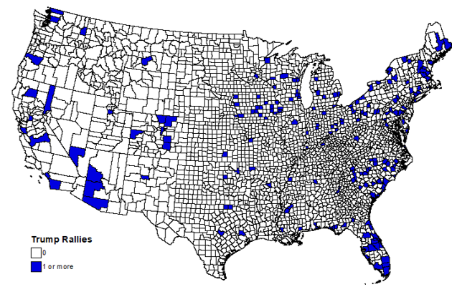

**Figure 2. County-Level Hate Incidents**

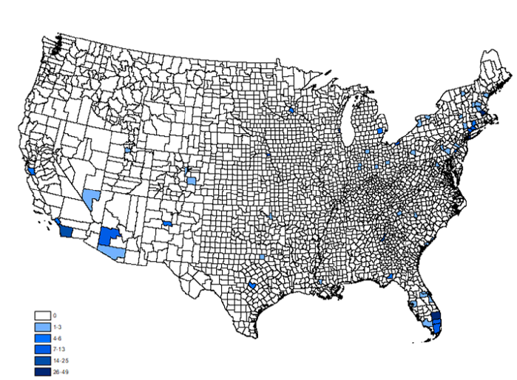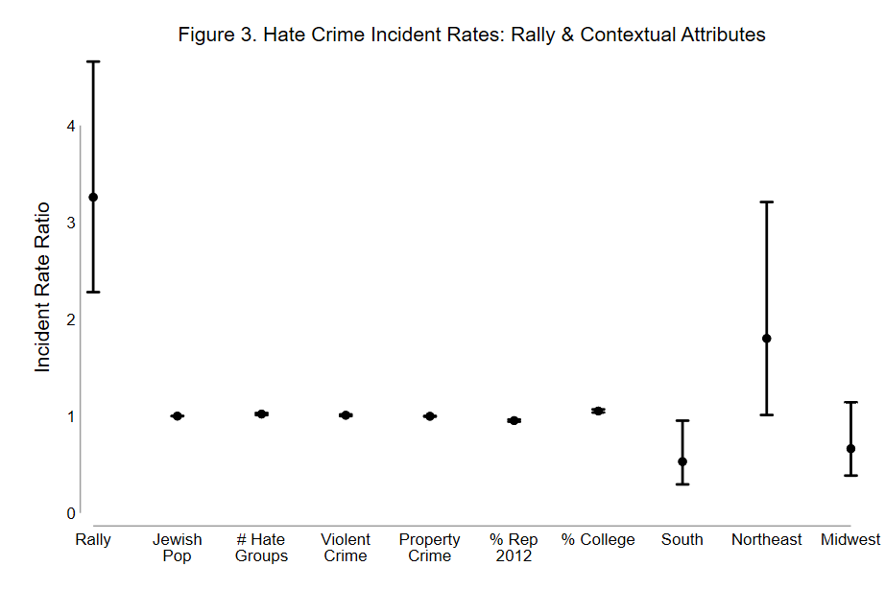

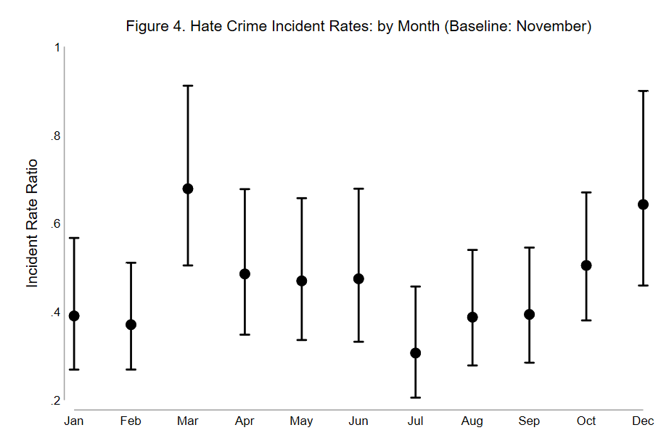

**Appendix. Number of Hate Incidents**

**(Matched Sample)**



1. Although Trump held a handful of rallies in 2015, comprehensive information regarding incidents targeting minorities is not available for 2015. Thus, we limited our examination to the 2016 campaign season. Note, the majority of Trump’s political rallies occurred in 2016 (275 rallies), not 2015 (48 rallies).
2. The ADL provides a H.E.A.T Map, which visually documents the location of the incidents reported. The H.E.A.T. Map can be found here: [https://www.adl.org/education-and-resources/resource-knowledge-base/adl-heat-map?gclid=Cj0KCQiA68bhBRCKARIsABYUGickjbICpdtUlv7cGjBf4CnZ9M8iiGcRQlogX](https://www.adl.org/education-and-resources/resource-knowledge-base/adl-heat-map?gclid=Cj0KCQiA68bhBRCKARIsABYUGickjbICpdtUlv7cGjBf4CnZ9M8iiGcRQlogXN_Xr8S3qCZSis4JDwgaAmhcEALw_wcB)

   [N_Xr8S3qCZSis4JDwgaAmhcEALw_wcB](https://www.adl.org/education-and-resources/resource-knowledge-base/adl-heat-map?gclid=Cj0KCQiA68bhBRCKARIsABYUGickjbICpdtUlv7cGjBf4CnZ9M8iiGcRQlogXN_Xr8S3qCZSis4JDwgaAmhcEALw_wcB) The page was last accessed on January 6, 2019. This website also provides the data by state in spreadsheet format. We compiled the data for all 50 states.
3. The location and date of the 2016 Trump political rallies were initially identified from <https://en.wikipedia.org/wiki/List_of_rallies_for_the_2016_Donald_Trump_presidential_campaign>. The page was last accessed on April 24, 2019. We cross-referenced the information on each rally listed to determine the accuracy of the information. Then we used Newsbank, an online archive of U.S. newspapers, to search for unreported 2016 Trump rallies. This rendered no additional rallies during the 2016 campaign season.
4. The likelihood ratio test on α indicates the existence of overdispersion; thus, confirming the negative binomial regression is preferred when compared to the Poisson regression. We also estimated a zero-inflated negative binomial regression. The results are consistent with the results presented here and are available upon request.
5. Violent crime is classified as murder/manslaughter, rape, robbery and aggravated assault. Property crime is classified as burglary, larceny-theft, motor vehicle theft, and arson. Both crime measures are based on the number of violent crimes per ten thousand residents.
6. The regional indicators are based on the U.S. Census Bureau’s classification.
7. We estimated the models alternating each month as the baseline. The results for all the non-temporal variables remained consistent across each estimation. As expected, only the coefficients and standard errors on the temporal dummies varied. We also estimated the models excluding the temporal dummies. The results are substantively consistent with the results presented herein.
8. The predict incident rates are based on setting all other covariates to their mean value.
9. Incident rate ratios (IRR) represent the exponent of the coefficient. IRRs higher than 1 reflect a positive rate, while IRRs less than 1 reflect negative rate.